**Naïve approach**

The core idea of the approach taken in the project is to apply evolutionary algorithms to create and fine-tune deep networks. As we discussed, a naïve approach was to directly use the NEAT algorithm (Neuro Evolution of Augmented Topology) to discover a multi-layered network that maps pixel information to actions in Doom.

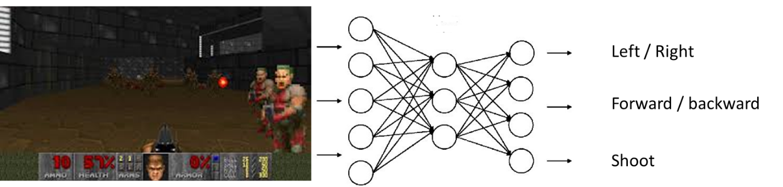

As suspected, this approach did not show very good results, mainly because of the high dimensionality of the input array (64x48 pixels image with 3 channels [RGB], which results in a total of 9216 units). The NEAT algorithm seems to have a hard time mapping those to reasonable actions.

**Two-steps approach**

With the assumption that it was the high dimensionality what stopped NEAT from performing here, I decided to see if there are ways of reducing this complexity using evolutionary algorithms. As it turns out, a couple of authors[1] have suggested that one way of doing so in the visual domain is by evolving *feature detectors*. The intuition behind it is to instead of using all of the raw pixel data on the neural network, one can reduce this information to the most important features present on images. Note that this is not a compression technique, such as the ones used with autoencoders; this is an approach that actively throws away some information and only keeps the fundamental features; nor it is an active feature detection technique -there is no preconceived knowledge on which features are worth keeping.

Using a genetic algorithm (with mutation and crossover as source of variation), one can evolve a neural network that learns those important features (whatever they might be). In essence, the network is reducing the dimensionality from 64x48x3 to a small feature vector (32, 64 or 128, for instance). In order to do that, the key is to select a fitness function that forces features to be as spread out as possible. From the work by Koutnik:

*“…the MPCNN is evolved without using a labelled training set. A set of k images is collected from the environment, and then MPCNNs are evolved to maximize the ﬁtness:*

*f = min(D) + mean(D)*

*where D is a list of all Euclidean distances, di,j = ||fi −fj||, ∀i > j, between k normalized feature vectors {f1 ...fk} generated from k images in the training set by the MPCNN encoded in the genome. This ﬁtness function forces the evolving MPCNNs to output feature vectors that are spread out in feature space, so that when the ﬁnal, evolved MPCNN processes images for the evolving controllers, it will provide enough discriminative power to allow them to take correct actions”.*

For example, let’s imagine we have 5 images, and the network is designed to output a vector of 3 features. On the first generation, a particular individual (candidate network) could output the following for each of the images:

|  |  |  |
| --- | --- | --- |
| IMAGE_1 | 1,1,1 | F1 |
| IMAGE_2 | 0,1,1 | F2 |
| IMAGE_3 | 1,0,0 | F3 |
| IMAGE_4 | 0,0,0 | F4 |
| IMAGE_5 | 1,0,0 | F5 |

To calculate the fitness function, first we calculate the distance between each of the Fs; Since we have 5 data points (one per image) we have the following distance comparisons:

|  |  |  |  |  |  |
| --- | --- | --- | --- | --- | --- |
|  | F1 | F2 | F3 | F4 | F5 |
| F1 | - | 1 | 1.4142 | 1.732051 | 1.4142 |
| F2 |  | - | 1.732051 | 1.4142 | 1.732051 |
| F3 |  |  | - | 1 | 0 |
| F4 |  |  |  | - | 1 |
| F5 |  |  |  |  | - |

Note that since the table is symmetric we do not have to concern ourselves with the bottom part. The fitness function of this particular network is then calculated using the minimum and the mean of all the distances values above. In this case, min(D) = 0, mean(D) = 1.2438753, hence the fitness is 1.2438753.

As the network evolves, feature vectors that are spread out (based on the images given) are favoured, which is equivalent to saying images will have as different outputs as possible from each other. The assumption here is that this will be enough to then build reasonable behaviour from.

In my approach, I am using a custom Genetic Algorithm to evolve the weights of a Convolutional Network. Part of the project will test which architecture is more appropriate, but at the moment I am using 4 convoluted layers each followed by a downsampling layer (max pool), ending with a fully connected layer of 32 units (which are the 32 features output).

But of course building a good feature detector is just half of the process. Once an appropriate feature detector is evolved, we are in a position to use the NEAT algorithm to evolve a network that maps the 32 features to a set of Doom actions (depending on the scenario, but typically left/right, forward/backward and shooting). This happens on each decision point; each frame, the image is passed through the feature detector CNN and then the output (vector of 32) is used as input of the controller network. The fitness function to evolve the controller is scenario-dependent, but normally it considers the number of enemies killed, the health packs and ammo picked, and the time to complete the level.

This is a high level diagram on my white board that presents the two steps approach

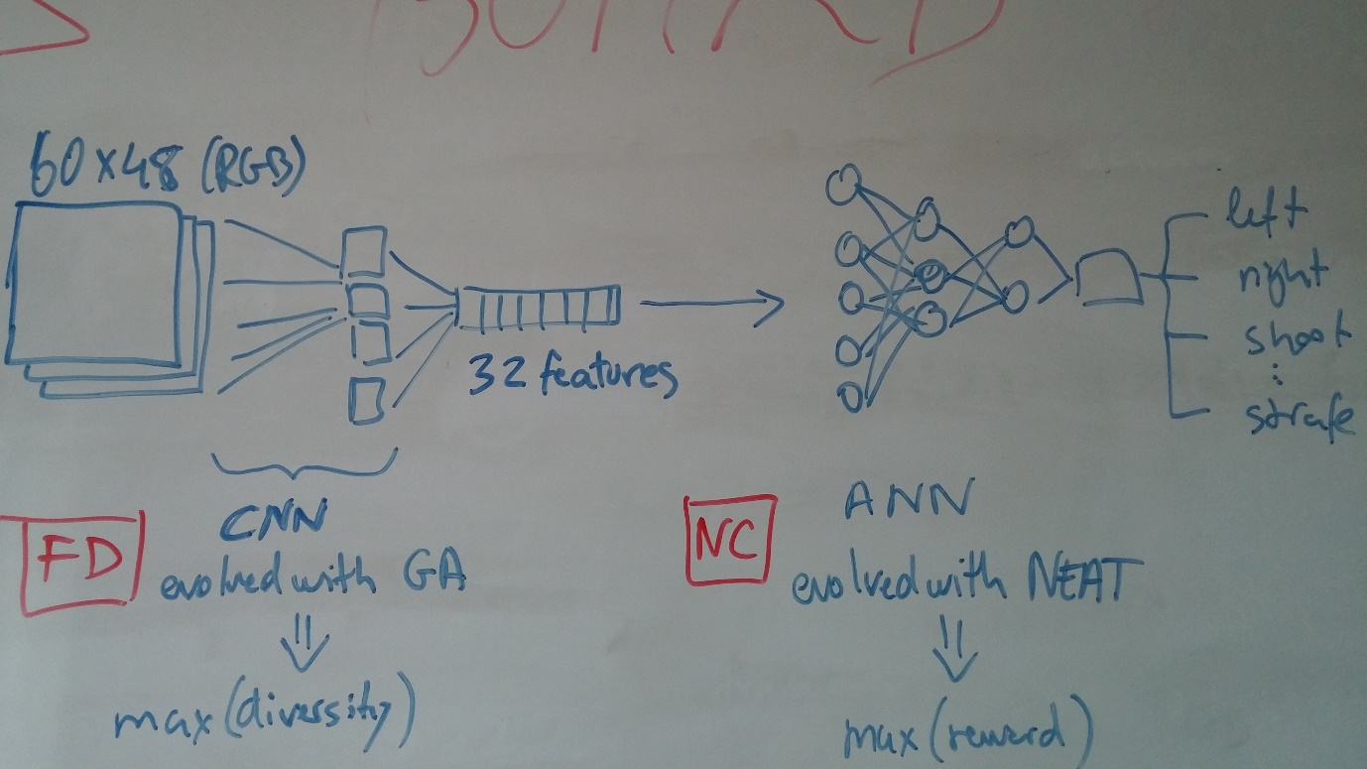

As you can see in the videos shared, the performance is far from perfect, but sufficiently good to suggest the goodness of the approach.

1. *Evolving Deep Unsupervised Convolutional Networks for Vision-Based Reinforcement Learning*, from Koutnik et al.; and *HyperNEAT and Novelty Search for Image Recognition*, from Kocmanek.